Exp.No-8

8. Write a C program for monoalphabetic cipher is that both sender and receiver must commit the permuted cipher sequence to memory. A common technique for avoiding this is to use a keyword from which the cipher sequence can be generated. For example, using the keyword CIPHER, write out the keyword followed by unused letters in normal order and match this against the
plaintext letters: plain: a b c d e f g h i j k l m n o p q r s t u v w x y z
cipher: C I P H E R A B D F G J K L M N O Q S T U V W X Y Z

Aim:
To implement a keyword-based Monoalphabetic Cipher using the keyword CIPHER for encryption.

Algorithm:
- Define the plaintext alphabet (A–Z).
- Define the keyword CIPHER.
- Generate the cipher alphabet by writing the keyword first, followed by the remaining unused letters.
- Read the plaintext from the user.
- Replace each plaintext letter with the corresponding cipher letter.
- Display the encrypted text.

Program:
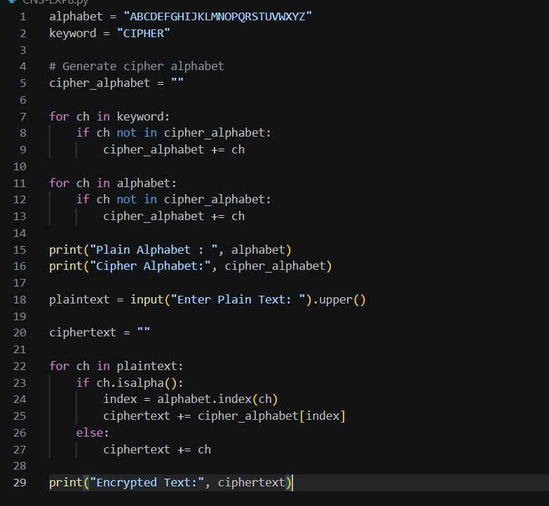

Output:
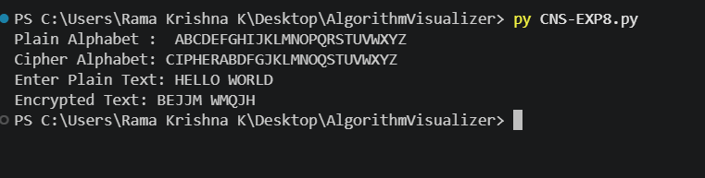

Result:
The keyword-based Monoalphabetic Cipher was successfully implemented using the keyword CIPHER.

